1. **Literature Review:**

The original Tensor Voting method was published by Medioni and Guy in 1997. Tensor Voting can be applied to both 2 dimensional and 3 dimensional data. In this paper, we only consider its 2D implementation to tackle the image segmentation problem. Tensor Voting becomes a very popular technique for edge detection because of its robustness towards to noise. Tensor Voting is usually implemented after a line detection due to two reasons. First, Tensor Voting is computational expensive. We can use an edge detector to identify potential edges, then let Tensor Voting to identify the true edges. However, this may reduce the robustness because the input for Tensor Voting may contain a lot of noise. Second, Tensor Voting can only work on the objects that are salient, which means white foreground and dark background. So, the outcome from an edge detector perfectly fits to this requirement. The following paragraph is the brief review of Tensor Voting procedure.



However, Loss proposed to apply Tensor Voting directly on images without applying an edge detector first. However, their procedures are not very convincing for two reasons. First, Loss applied simple threshold method to pre-label some pixels to be background. The formula is I xy / I white. If the value is above an arbitrary value, they label it as foreground; otherwise, it is considered as background. Second, Loss used synthetic images, instead of real lab images. The problem is that their sythetic images look the same as the images that have been applied with an edge detector. Therefore, their claim is not valid. However, I am inspired by their procedure because I see the potential of using Tensor Voting as an object segmentation technique.

Many works were built on this technique, and many variants were proposed to speed up Tensor Voting’s computation. My proposed method have three main difference to the original work:

1. I propose no decay function because decay function does not contribute
2. Replace SV + BV with a special designed kernel and projection function. All neighbour around the targeted pixel are included.
3. Only target pixel only take the neighbour pixels who are close to itself. This helps to converge and eliminate the side effect of blurring.

There are three main contributions to the field. First, we fully utilize matrix manipulation tricks to speed up the algorithm. Second, our design simplified the algorithm without compromising the accuracy. Third, we are the first attempt to apply Tensor Voting to a segmentation problem.

1. **Proposed Method:**

We will introduce how our algorithm is different from original version, then provide diagram and code to illustrate the implementation.

* 1. Variance 1 -- No decay function

No authors mentioned in their paper how far their allow Tensor Voting to collect information from its neighbour. The decay function serves as a weighting function. The further the voter pixels are from the targeted pixel, the less value they are controbuting to the target tensor. So, the question is how far the decay function is still contributing. I use a 7x7 matrix to illustrate

For σ = 1, we can clearly see that this decay function is useless. Only the two horizontal voters contribute a little bit to the targeted pixel.

|  |  |  |  |  |  |  |
| --- | --- | --- | --- | --- | --- | --- |
| **2.2688e-10** |  |  |  |  |  | **2.2688e-10** |
| **4.5280e-07** | **5.1723e-05** |  |  |  | **5.1723e-05** | **4.5280e-07** |
| **3.1918e-05** | **0.0046** | **0.0848** |  | **0.0848** | **0.0046** | **3.1918e-05** |
| **1.2341e-04** | **0.0183** | **0.3679** | **Voter** | **0.3679** | **0.0183** | **1.2341e-04** |
| **3.1918e-05** | **0.0046** | **0.0848** |  | **0.0848** | **0.0046** | **3.1918e-05** |
| **4.5280e-07** | **5.1723e-05** |  |  |  | **5.1723e-05** | **4.5280e-07** |
| **2.2688e-10** |  |  |  |  |  | **2.2688e-10** |

For σ = 18, the values are boosted dramatically. This is the suggested value by Medioni. We can see that there are very minor differences among the values. Therefore, it is not worth for the computation to obtain these weights.

|  |  |  |  |  |  |  |
| --- | --- | --- | --- | --- | --- | --- |
| **0.9137** |  |  |  |  |  | **0.9137** |
| **0.9384** | **0.9236** |  |  |  | **0.9236** | **0.9384** |
| **0.9610** | **0.9532** | **0.8159** |  | **0.8159** | **0.9532** | **0.9610** |
| **0.9726** | **0.9877** | **0.9969** | **Voter** | **0.9969** | **0.9877** | **0.9726** |
| **0.9610** | **0.9532** | **0.8159** |  | **0.8159** | **0.9532** | **0.9610** |
| **0.9384** | **0.9236** |  |  |  | **0.9236** | **0.9384** |
| **0.9137** |  |  |  |  |  | **0.9137** |

I also tried with σ = 30. The numbers are not changing much. For example, the ones at the furthest corners are near to 0.96. No values exceed 1 due to the decay function design. Based on the illustration, we can tell that decay function is not contributing significantly. Therefore, I propose to remove the decay function.

3.2 Variance 2 -- Special Kernel and Projection Matrix

A new tensor is the sum of SV and BV. As we introduced in Section 2, BV is the integration of SV. The integration is extremely messy due to the complex structure of SV. We need to integrate over θ. Both the decay function and projection matrix contain θ. It is impossible to apply integration directly to SV. Since we already proved that the decay function is playing an important role for Tensor Voting. We will drop the term and only apply integration to the project matrix. The outcome is very messy but achievable. So, we obtained:

**Projection Matrix**

|  |  |
| --- | --- |
| sin(2θ)^2 | - sin(2θ) * cos(2θ) |
| - sin(2θ) * cos(2θ) | cos(2θ)^2 |

|  |  |
| --- | --- |
| θ/2 - sin(4θ)/8 + sin(2θ)^2 | (cos(2θ)^2) / 4 - sin(2θ) * cos(2θ) |
| (cos(2θ)^2) / 4 - sin(2θ) * cos(2θ) | θ/2 + sin(4θ)/8 + cos(2θ)^2 |

**Integrate Over θ + SV Projection Matrix**

To be clear, the θ refers to radian, not degree. The following images are generated with different projection matrix -- 1) SV only, and 2) SV + BV. The result shows that SV + BV method is more robust than SV-only projection, but it suffers lower recall at the same time. Some authors have proposed different methods to approximate BV. We will not implement them. The idea we want to convey is that BV may not introduce new information because it only utilizes the known information from SV. We think the vertical neighbors are equally important too, and we should not use BV to approximate or infer what they are.

SV Only SV + BV

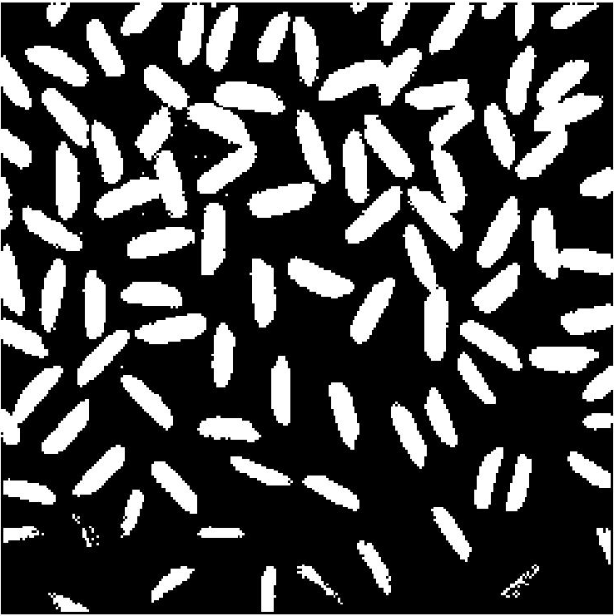 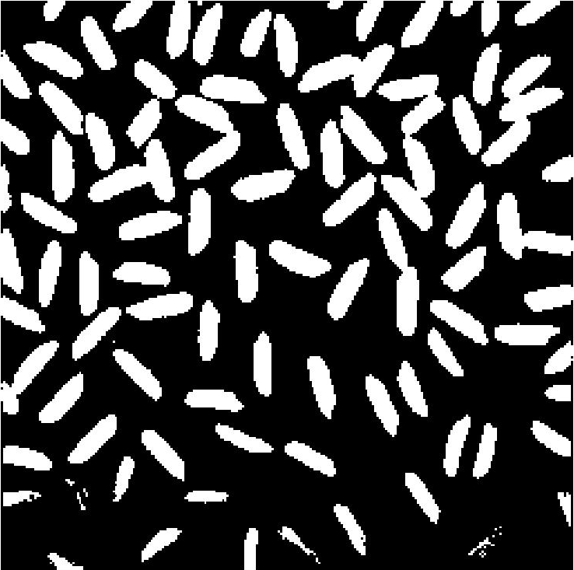

We proposed to use all neighbour around the target pixels. Although Medioni mentioned that the effective range is between -pi/4 and pi/4, the projection matrix is just a way to encode neighbors’ information.

I used a real lab image to compare the performance between my proposed kernel and the original version. The first row is

SV + BV Sin + Cos

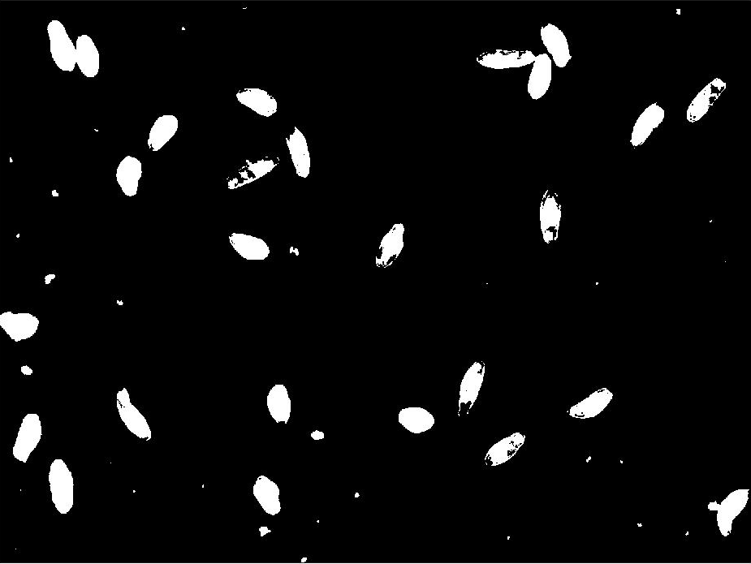 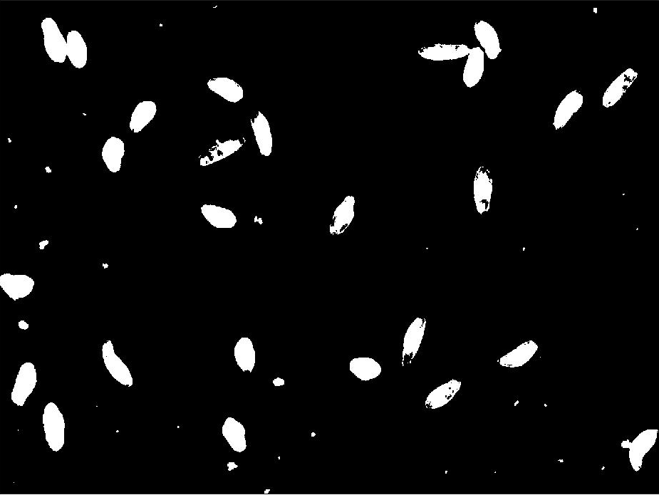

 

3.3Variance 3 -- Selective Neighbour

Tensor Voting can be applied iteratively. In each iteration, the output values that are lower than an arbitrary threshold value will be labeled as background. Although it seems that Tensor Voting is performing removing noise, it is actually blurring the pixel values. To illustrate the idea, I iterate 10 times over the rice image without removing any pixel value. I normalized the output between 0 and 255 in order to generate an image, instead of applying a thresholding value to generate a salience map. The second image is the outcome after 10 iterations. The third image is when I apply a simple thresholding value. More iterations only leads to a blurry outcome. Therefore, I propose a selective voting kernel.

The idea is to align the targeted pixel to agree with its majority neighbors, instead of taking nearly same amount of information from all its neighbor, which causes blurring. For example, if I decide to apply a 3x3 filter, there are

 